Paper Number 01

IMULSIFIERS Braking System Report
Mr. Aditya Ganjapure
Mr. Hrishikesh M. Sathe
Mr. Mandar Deshmukh
Members, IMPULSIFIERS

Copyright © 2015 IMPULSIFIERS
ABSTRACT
The analysis and testing of the components of braking system gives us an idea that how components are going to respond when the braking system is in operation. This gives us a brief picture of the braking force that can be applied and which the system can sustain. Also in braking, heat is generated and hence temperature is an important factor; considering which the system has been designed.
INTRODUCTION
The Braking system of any vehicle is a system to bring the vehicle at rest from a given velocity as and when required. Proper importance must be given to it. Structural and thermal analysis of the components is also presented in this paper. This paper studies the Braking system and designs it keeping in consideration the rule constraints as mentioned in the SUPRA 15 rulebook.
Braking Calculations
Vehicle Dimensions and initial values:
Mass of vehicle = 360kg
L (wheel base) = 1.80 m
L₁ (length of the CG from the front axle) = 1.03m
L₂ (length of the CG from the rear axle) = 0.77m
H (height of the CG from the ground) = 0.25m
F_{r} (coefficient of rolling resistance) = 0.02
(Obtained from the Chassis team)

1. Calculating the Static axle Loads:

By taking moment about the front axle, we get,
Static Rear Axle Load = 2020.86 N
Therefore,
Static Front Axle Load = 1510.74 N

2. Calculating the Dynamic axle Loads

M_{fdyn} = ((1-ψ)+Xa)M
X = h/W_{b}
ψ = Static rear axle load/ Total vehicle mass.
a = average deceleration in g units.
Therefore,
X=0.25/1.80
= 0.138

Psi = 2020.86/(360*9.81)
=0.572

M_{fdyn} = 184.38 N
M_{rdyn} = 175.62 N
3. Calculating the maximum braking force on the front and the rear axles:

The maximum braking force that the tire-ground contact can support is determined by the normal load and the coefficient of road adhesion. With four-wheel brakes, the maximum braking forces on the front and rear axles
Is given by (assuming the maximum braking force of the vehicle is given by Fbmax = uW)

Therefore,

F_{bfmax}=0.7*360*9.81(0.77+0.25(0.7 + 0.02))/1.80
=1304.73 N

F_{brmax} = 0.7*360*9.81(1.03-0.25(0.7 + 0.02))/1.80
=1167.39 N

The total braking force F_{b}is:
F_{b}= 2472.12 N

The braking force distribution is:
52.77% on the front axle
47.22% on the rear axle

Figure No. 1 Forces acting on a two-axle vehicle during braking

From the above graph, the maximum deceleration of the vehicle prior to lock-up will be 0.61g.

4. Braking efficiency

Braking efficiency is defined as the ratio of the maximum
Deceleration rate in g units achievable prior to any tire lock-up to the
Coefficient of road adhesion u, and is given by
= (a/g)/u
=0.61/0.7
=0.871
i.e 87.1%

5. Calculating the Stopping distance

The stopping distance ‘S’ is given by:

C_{ae} = 0.5*p*C_{d}*A

Projected area A = 5000mm²
Density of air p = 1.2kg/m³
Drag coefficient C_{d} = 0.6

C_{ae}= 0.18

Substituting the values in the above equation, the stopping distance comes out to be 13.95m

Drivers reaction time = 0.3 seconds

Total stopping distance
= 13.95*0.87 + 0.3*13.95
= 16.32m

6. Calculating the stopping time

Stopping time = Velocity/ deceleration
= 13.88/(0.61*9.81)
= 2.32 seconds.

Assuming 32 kgf to be the normal pedal force and the Pedal ratio to be 5
Pedal force = 32*9.81
=313.92 N
The Force transmitted to the master cylinder = 1569.6 N

7. Specifications of Braking System:
The Braking circuit will be diagonal so as to ensure proper stopping of the vehicle in case of brake failure.
Disc size = 220 mm diameter
Disc used will be of Honda CB Trigger
In Supra 14, Aviator discs of 190 mm diameter were used. However, the brake pin failed several times as the disc size was small.
Hence, an increased disc diameter of 220 mm will be used.

Dual tandem master cylinder will be used (Maruti 800)
Bore Diameters = 19.05 mm and 21.02 mm
Dual tandem master cylinders save space as a single master cylinder will provide braking pressure to all the wheels.
Caliper piston diameter: 27 mm ID/ 25 mm ID of Bullet
Due to caliper orientation constraints, Bullet calipers will be used. The main reason is to achieve a higher location of the bleed valve.

Resuming the calculations,
For 19.05 mm bore,
Pressure generated = 1569.6/ ((3.14/4)*19.05²)
=5.5 MPa
For 21.02mm bore,
Pressure generated = 1569.9/((3.14/4)*21.02²)
=4.52 MPa

Assuming no pressure loss along the brake lines, this pressure will be incident on the caliper piston

Force on the brake pad = Pressure on the caliper pistons * Area of caliper pistons
( Bullet calipers on the right hand side wheels w.r.t drivers position )

LHS Front Wheel 1:
5.5*2*(3.14/4)*(27²-25²) = 898.48 N
898.48*2*0.4 = 718.78N

RHS Front Wheel 2:
4.52*2*(3.14/4)*(27²-25²) = 738.39 N
738.39*2*0.4 = 590.71N

RHS Rear Wheel 3:
5.5*2*(3.14/4)*(27²-25²) = 898.48 N
898.48*2*0.4 = 718.8N

LHS Rear Wheel 4:
4.52*2*(3.14/4)*(27²-25²) =738.39 N
38.29*2*0.4 = 590.71N

8. Torque Calculations
Tire specifications
Front: 145/80 R12 Diameter = 536.8mm
Rear : 165/65 R13 Diameter = 544.7 mm
Brake torque = (F_{b})*R/r
R= Static laden radius of wheel
r = speed ratio
(F_{b}) = Braking force on the wheel
T₁ = 718.78 *(0.51/(2*1)) = 183.28 N-m
T₂ = 590.71*0.52/(2*1) = 153.58N-m

9. Calculating the total energy of the system (Rotational energy)
Rotational energy = 0.3*0.5*M*V²
M=360kg ; V=25kmph = 6.94 m/s( Mean velocity of the vehicle)
Therefore,
T.E = 0.3*0.5*360*6.94²
= 2600 J
Stopping time = 2.3 sec
Power = T.E/ St. time
= 2600/2.3
= 1130W
(this power was the heat input for steady state thermal analysis of the disc)
Material Properties
Material of knuckle:
ENAW AlSiMg(A)
Syt = 220MPa
Sut = 260MPa
Material of Hub:
Syt = 320 MPa
10. Thermal Analysis of Disc Brake
Steady state thermal analysis of the disc:
Power input = 1132W;
h= 40W/m²K (convective heat transfer coefficient)

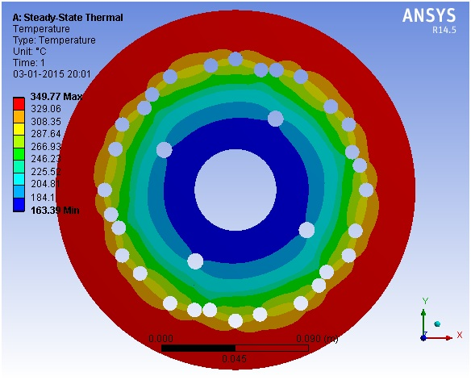

Fig No. 1: Steady state thermal anaysis
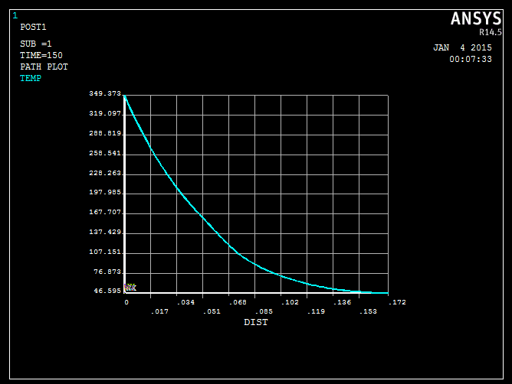
Fig No. 2 Transient thermal analysis

Transient thermal analysis:
Temperature input =349.77 deg C.
h= 40W/m²K

11.CREO models

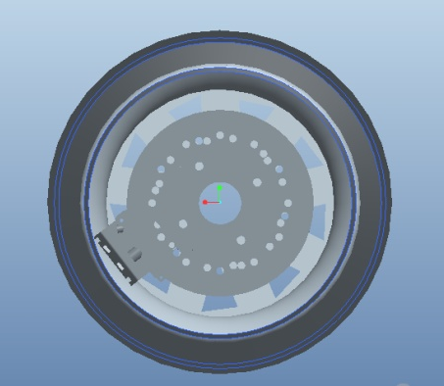
Fig No.3 Front View

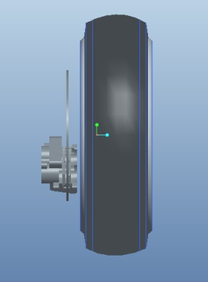
Figure No.3 Side View
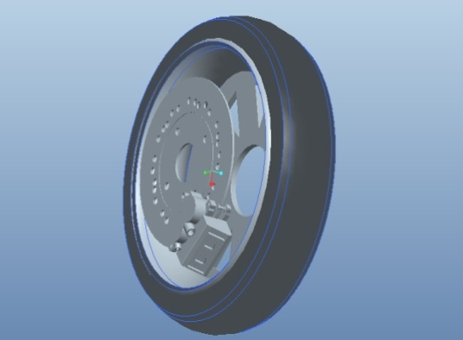
Figure No.4 Isometric View
12. Structural analysis of Hub and Knuckle
FigNo. | Component | Condition | Load | FoS | Max Deflection
1 | Hub | Impact | 6000 | 1.6 | 6.74e-2
2 | Hub | Braking | 4000 | 4.3 | 4.094e-2
3 | Knuckle | Impact | 6000 | 1.8 | 6.906e-2
4 | Knuckle | Braking | 4000 | 5.17 | 1.839e-2

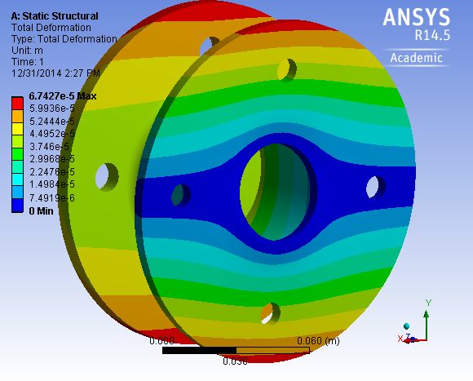
1(a) DEFORMATION IN BENDING HUB

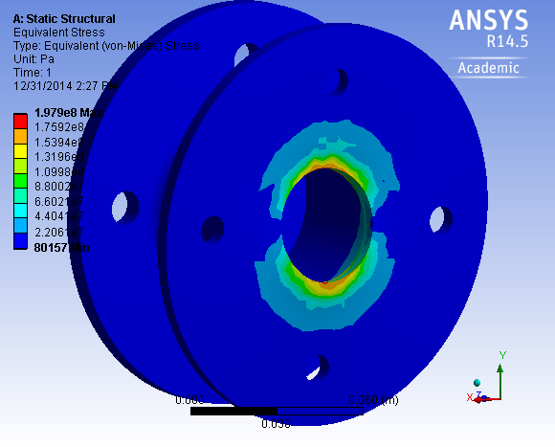
1(B)STRESS IN HUB BENDING

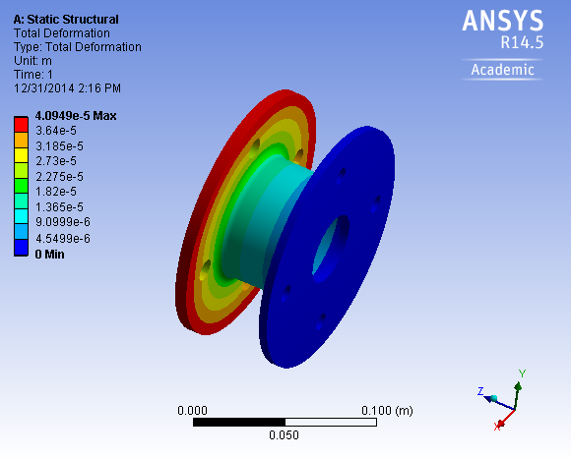
2(A) DEFORMATION OF HUB UNDER BRAKING

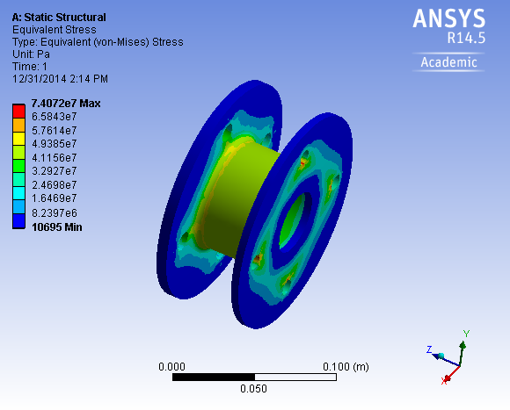
2(B). STRESS IN HUB UNDER BRAKING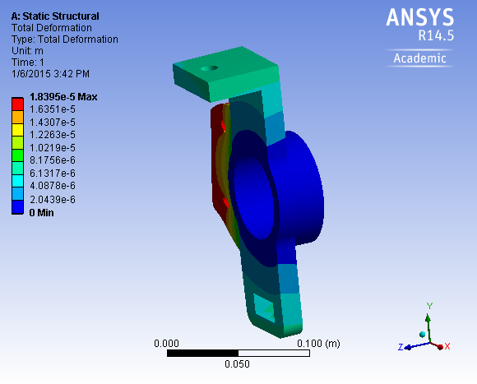
4(B) DEFORMATION IN KNUCKLE UNDER BRAKING

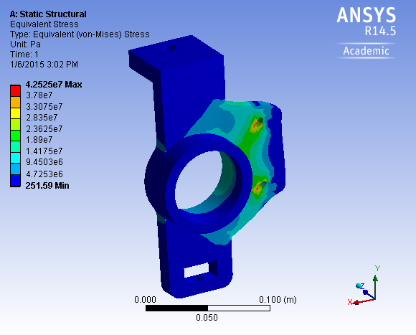

4(B) STRESS IN KNUCKLE UNDER BRAKING

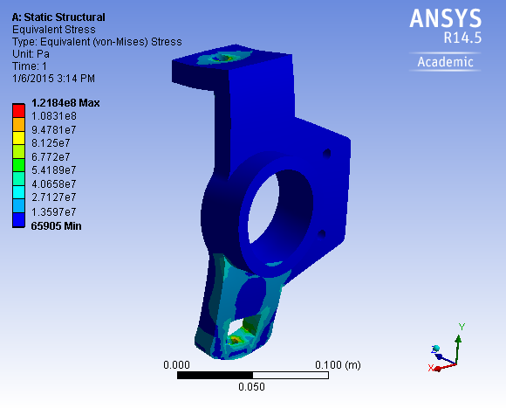

3(B) STRESS IN KNUCKLE UNDER BENDING

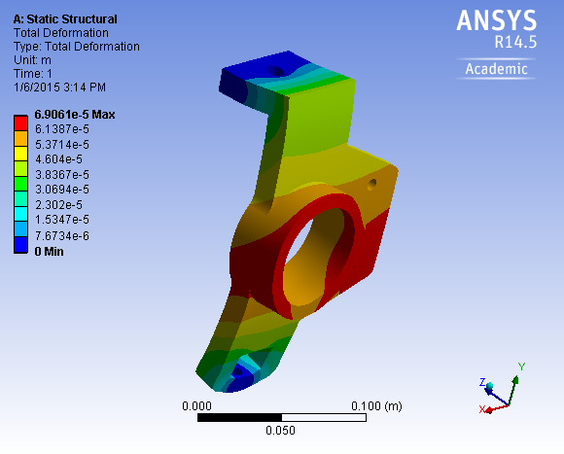
3(B) DEFORMATION IN KNUCKLE UNDER BENDING

Conclusion
For any vehicle, its braking system is a very integral and therefore its design and analysis should be given proper importance. Complacent and a casual analysis of the braking system, therefore becomes unacceptable.
This paper makes the thermal as well as the structural analysis of the disc brake system of a four wheeler. Taking proper assumptions, various braking parameters are defined and the system is finally designed.
Acknowledgement
The author would like to thank Prof. R.U. Patil,
Prof. B.C Bissa, the IMPULSIFIER team members and professors of RCOEM, Nagpur for their valuable help and support during the work on this paper.
REFERENCES

http://suprasaeindia.org/
http://suprasaeindia.org/download.html
http://suprasaeindia.org/discussion-forum.html
http://www.velammaltrust.com/pdf/SUPERNOVA.pdf

